Sequence Diagrams:
Search Page:
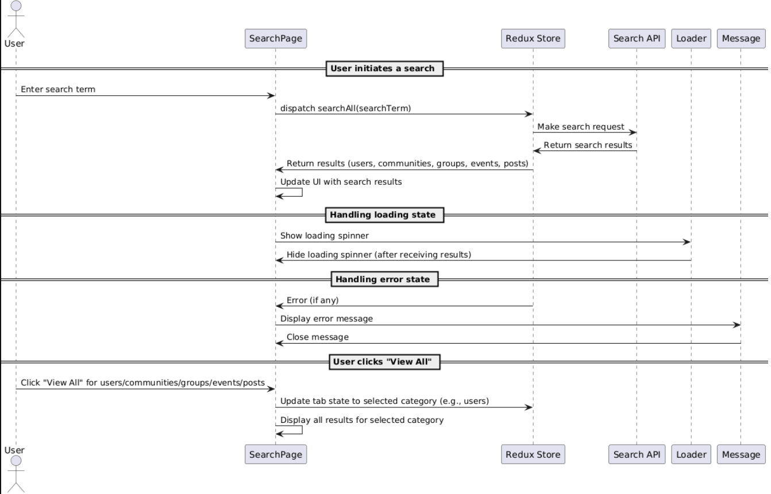

Connection Page:
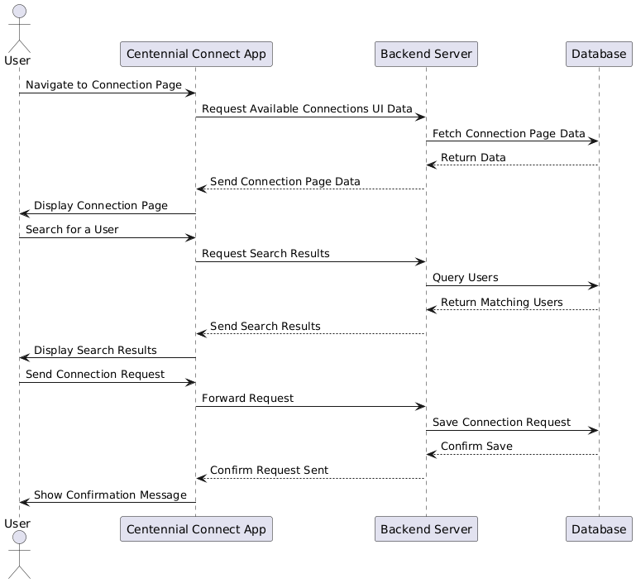

Connection Database:
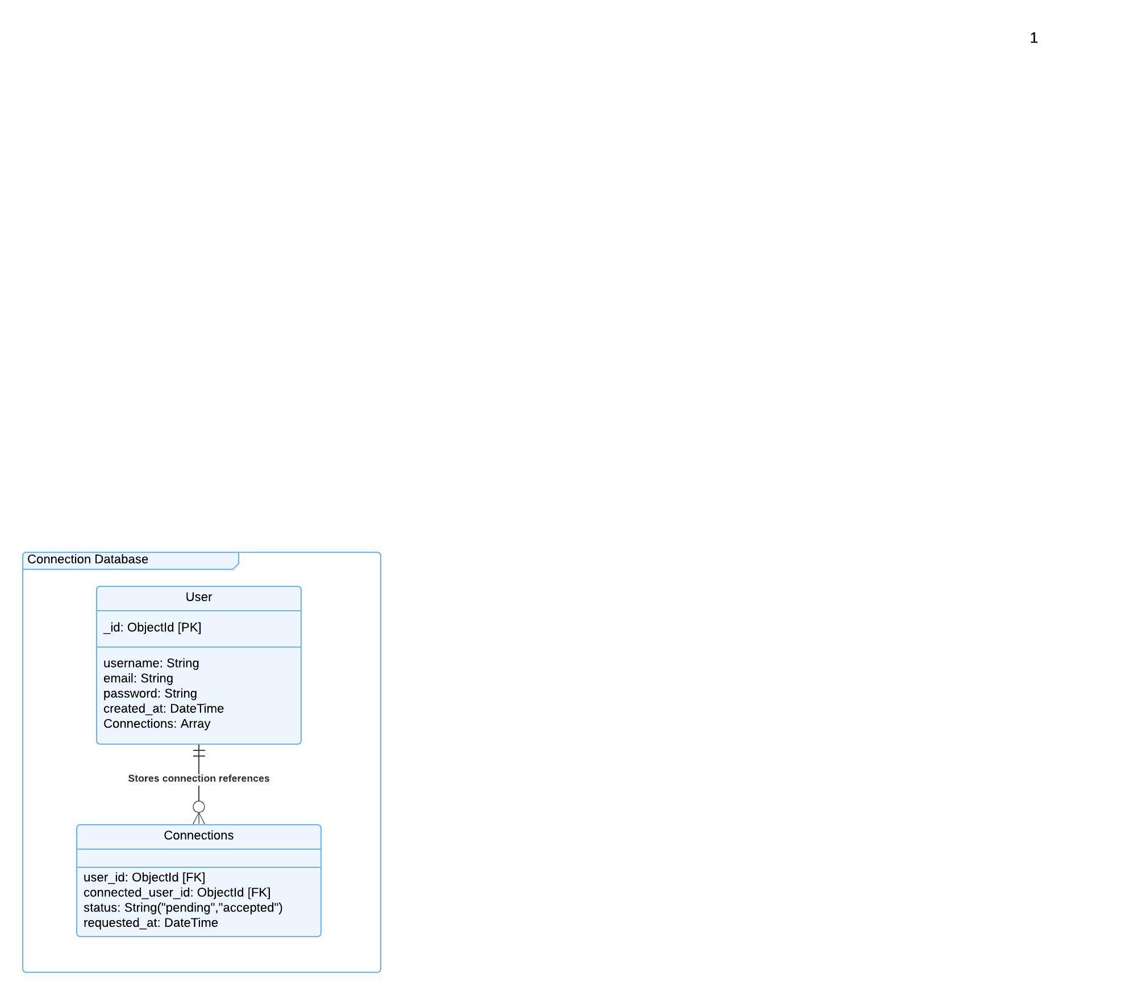
Event Joining:
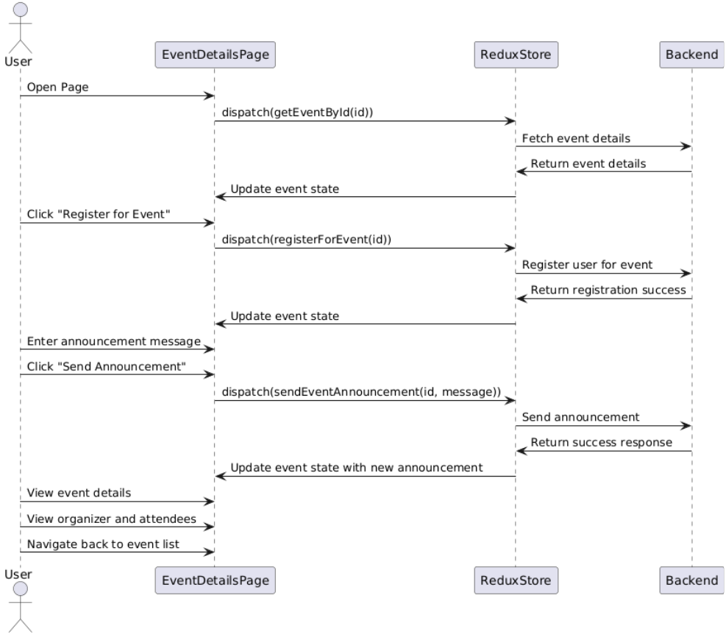

Functional Requirements (FRs)
Search Functionality
- FR1: The system shall allow users to search for events using keywords and filters.
- FR2: The system shall display search results based on user queries.
- FR3: The system shall fetch event details from the database upon user request.
- FR4: The system shall allow users to refine search results using filters.
- FR5: The system shall return relevant events based on search queries.
Connection Functionality
- FR6: The system shall allow users to send connection requests to other users.
- FR7: The system shall validate and store connection requests in the database.
- FR8: The system shall allow users to accept or reject connection requests.
- FR9: The system shall notify users when they receive a new connection request.
- FR10: The system shall display a list of confirmed connections to the user.
Event Joining Functionality
- FR11: The system shall allow users to join an event from the event details page.
- FR12: The system shall check event availability before confirming participation.
- FR13: The system shall store the user’s event registration in the database.
- FR14: The system shall send a confirmation notification upon successful registration.
- FR15: The system shall allow users to cancel their event registration if needed.

Non-Functional Requirements (NFRs)
Performance & Reliability
- NFR1: The system should return search results within 2 seconds.
- NFR2: The system should handle 500 concurrent users searching for events without performance degradation.
- NFR3: The system should support real-time updates for connection requests and event registrations.
Security & Data Integrity
- NFR4: User data and connection requests should be stored securely with encryption.
- NFR5: The system should use HTTPS to ensure secure communication.
- NFR6: The system should implement access control to prevent unauthorized event joining.
- NFR7: Users should only be able to join an event if they meet the event criteria (e.g., availability, permissions).

